Parth Babbar

anti-money laundering

**Introduction:**

Money laundering, the process of disguising criminal funds as lawful, poses a substantial danger to the integrity of global financial institutions. To tackle these criminal operations, governments throughout the world have implemented strict anti-money laundering (AML) rules. This study provides a detailed examination of AML legislation in the United States, including legislative frameworks, enforcement methods, significant data, and developing trends.

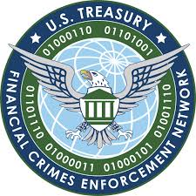

**History:**

The United States has established a comprehensive legislative framework to combat money laundering and terrorist financing activities. Key statutes include the Bank Secrecy Act (BSA) of 1970, the Money Laundering Control Act (MLCA) of 1986, and the USA Patriot Act of 2001. These rules require financial institutions to follow severe customer due diligence (CDD) procedures, report questionable transactions, and keep detailed transaction records. In addition, regulatory entities such as the Financial Crimes Enforcement Network (FinCEN) and the Office of Foreign Assets Control (OFAC) supervise AML compliance and enforcement.  
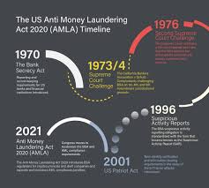

**Statistics:**

1. **Scale of Money Laundering:** According to estimates, money laundering operations in the United States total between $500 billion and $1 trillion every year.
2. **Primary Targets:** Traditional financial institutions, including banks and securities firms, bear the brunt of money laundering operations, accounting for around 55% of all reported suspicious transactions.
3. **Threats:** Recent research has revealed alarming developments in non-financial sectors such as real estate, luxury products, and virtual currencies, indicating the changing nature of money laundering schemes and the need for increased monitoring across industries.  
     
   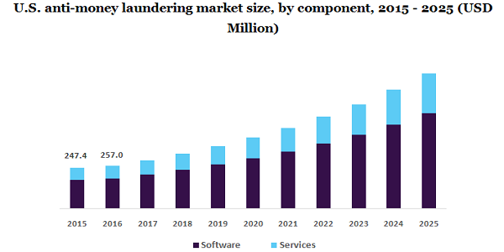  
     
     
   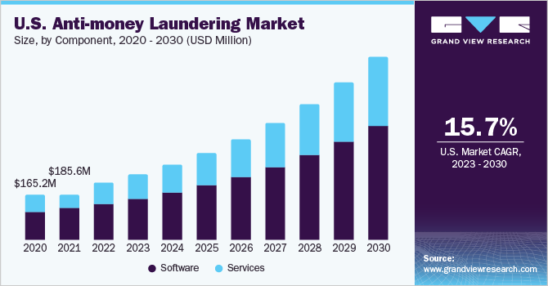

**Emerging Trends & Challenges:**

1. **Technological Advancement:** Blockchain technology and cryptocurrencies provide more transparency and accountability, but they also open up new avenues for money laundering.
2. **Cross-Border Cooperation:** To address the worldwide breadth of money laundering, states must work together and share information.
3. **International Partnerships:** Multilateral initiatives and cooperation are critical for strengthening anti-money laundering (AML) regulations and successfully combating transnational threats.

**Future Outlook:**

The future of AML regulation will most likely be defined by continued technical advancements, regulatory reforms, and international collaboration initiatives. Potential advancements include the use of artificial intelligence and machine learning techniques for AML compliance, the harmonisation of AML regulations across countries, and expanded public-private collaborations to combat financial crime.

**Conclusion:**

Finally, anti-money laundering measures are critical to ensuring the integrity and stability of financial institutions. The United States has established a strong set of rules and regulations to identify, prohibit, and disrupt money laundering operations. However, the ever-changing nature of financial crime demands constant awareness, teamwork, and creativity in order to effectively combat money laundering in the coming years.